Facial Chemical Burn Following Self-Administration of 80% Trichloroacetic Acid Solution: A Case Report and Its Management

Mohammad Jamshidi1*, Fatemeh Judy1
1*.Faculty Member, Department of Dermatology, School of Medicine, Hamadan University of Medical Sciences, Hamadan, Iran.
1.Dermatology Resident, School of Medicine, Hamadan University of Medical Sciences, Hamadan, Iran.

Extended Abstract

Introduction

Acne vulgaris is a chronic inflammatory disease of the pilosebaceous unit that commonly begins during adolescence and may persist into adulthood. It is one of the most prevalent dermatologic disorders worldwide and can manifest with both inflammatory and non-inflammatory lesions, primarily affecting the face, trunk, and upper extremities [1–4]. Delayed treatment of acne significantly increases the risk of permanent scarring and its associated psychosocial burden [5,6]. Various therapeutic approaches have been developed for the management of acne scars, including topical agents, surgical procedures, laser resurfacing, and chemical peeling techniques [7–12].

Chemical peeling has been used for centuries to improve skin appearance and quality, with historical descriptions dating back to ancient Egyptian medicine [13]. Among available peeling agents, trichloroacetic acid (TCA) occupies a prominent role because of its efficacy, predictability, and overall safety profile when administered by trained professionals [14,15]. TCA is commonly utilized in different concentrations for skin rejuvenation and scar management. The TCA CROSS (Chemical Reconstruction of Skin Scars) technique employs focal application of high-concentration TCA (80–100%) to induce controlled chemical coagulation and stimulate dermal remodeling in deep atrophic acne scars, particularly ice-pick and boxcar scars [18,22]. Although generally effective when performed under medical supervision, inappropriate use of concentrated TCA may result in severe complications, including chemical burns, post-inflammatory hyperpigmentation (PIH), and permanent scarring [15,24]. The present report describes a case of facial chemical burn following unsupervised application of 80% TCA for acne scar treatment and discusses its successful management through a multimodal regenerative approach.

Case Presentation

A 20-year-old female with Fitzpatrick skin phototype IV presented to a specialized dermatology center with signs and symptoms of facial chemical burn. She had a history of atrophic acne scars, predominantly ice-pick scars, and had initially been considered a suitable candidate for physician-performed TCA CROSS therapy. The planned treatment consisted of four to six sessions of focal application of 80% TCA at intervals of four to six weeks.
However, in pursuit of more rapid and dramatic improvement, the patient independently applied an 80% TCA solution at home using a cotton applicator directly over the affected areas. Immediately after application, she developed extensive frosting and severe burning sensations. Approximately 20 hours later, after washing her face with water, she sought dermatologic consultation.
Physical examination revealed a chemical burn involving the left malar and submalar regions, accompanied by erythema, brownish discoloration, and persistent burning sensation. The lesion measured approximately 5 × 6 cm. No discharge, secondary infection, or systemic manifestations were observed (Figure1).
Initial management focused on controlling acute inflammation and preventing further tissue injury. The patient received oral prednisolone (5 mg daily for five days), topical betamethasone lotion twice daily for three days, Alpha ointment containing henna and turmeric extracts, and zinc oxide ointment. Strict photoprotection, including regular sunscreen use and sun avoidance measures, was recommended from the beginning of treatment (Figure2).

After one week, once the acute inflammatory phase had subsided, nightly Kligman’s formula consisting of hydroquinone, tretinoin, and a topical corticosteroid was initiated to prevent and treat post-inflammatory hyperpigmentation. Regenerative therapy was subsequently introduced. Platelet-rich plasma (PRP) injections were administered weekly for four consecutive weeks(Figure 3,4). Following completion of PRP treatment, platelet-rich fibrin (PRF) therapy was performed sequentially, including PRF dressing during week six, PRF injection during week seven, and a second PRF dressing during week eight. The overall treatment course lasted eight weeks and resulted in progressive clinical improvement characterized by reduction of erythema, improvement of pigmentation abnormalities, enhanced skin texture, and satisfactory tissue restoration(Figure 5)
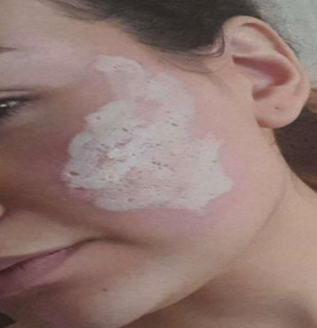 Figure 1. Clinical appearance immediately after the TCA-induced chemical burn

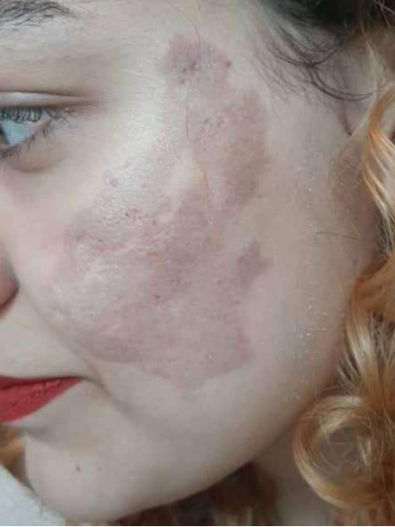Figure 2  Week 2 before initiation of PRP therapy. | 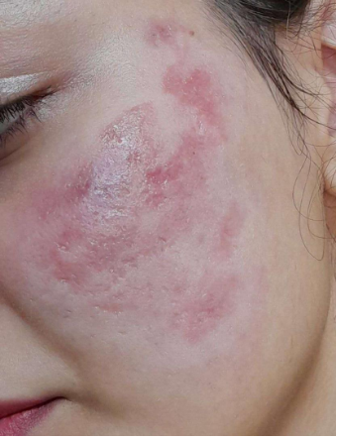 Figure 3  Clinical appearance after two sessions of PRP therapy. | 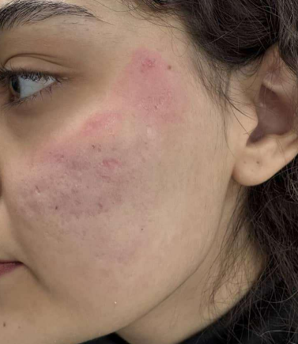 Figure 4  Clinical appearance after four sessions of PRP therapy. | 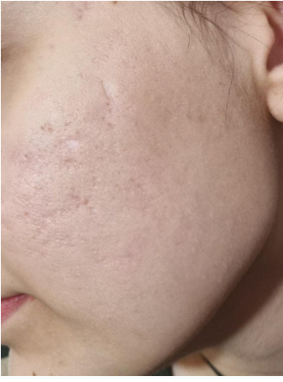 Figure 5  Clinical outcome at the end of treatment.

Discussion

Chemical peeling remains an established therapeutic modality for acne and acne scars. Common peeling agents include salicylic acid, glycolic acid, pyruvic acid, lactic acid, mandelic acid, Jessner’s solution, TCA, and phenol [16,17]. Medium-depth chemical peels produce controlled epidermal and papillary dermal injury, leading to regeneration of epidermal and dermal structures. TCA concentrations around 30% have demonstrated efficacy and safety in the treatment of mild-to-moderate acne scarring [18–21].

For deeper atrophic scars, particularly ice-pick and boxcar scars, the TCA CROSS technique has emerged as an effective treatment option by stimulating neocollagenesis and tissue remodeling [22,23]. Nevertheless, as illustrated in the present case, the use of highly concentrated TCA outside professional settings may produce devastating consequences. Previous reports have documented severe chemical burns, permanent scarring, and pigmentary alterations following inappropriate application of concentrated TCA preparations [15,24]. These observations underscore the importance of patient education and professional supervision in cosmetic dermatologic procedures.

An important aspect of this case was the implementation of a staged multimodal treatment protocol. Early administration of anti-inflammatory therapy likely contributed to limiting tissue damage and facilitating wound stabilization. In addition, proactive management of PIH with Kligman’s formula was particularly relevant because darker skin phototypes are more susceptible to pigmentary complications following cutaneous injury.

The most innovative component of the therapeutic strategy was the sequential use of platelet-derived regenerative products. PRP contains multiple bioactive growth factors, including platelet-derived growth factor (PDGF), transforming growth factor-beta (TGF-β), and vascular endothelial growth factor (VEGF), which promote angiogenesis, fibroblast proliferation, collagen synthesis, and tissue repair [25,26]. PRF further enhances regenerative potential by providing a three-dimensional fibrin scaffold that allows sustained release of growth factors over time. The favorable clinical response observed in this patient suggests that combined PRP and PRF therapy may serve as a valuable adjunctive treatment in selected cases of chemical burn injury.

Furthermore, previous studies investigating chemical burn management have emphasized the importance of early intervention, appropriate wound care, and immediate irrigation following chemical exposure to minimize tissue damage and reduce long-term sequelae [27,28]. The present case supports these recommendations and highlights the potential benefits of integrating regenerative medicine into conventional burn management protocols.

Conclusion

This case report highlights the potentially severe and occasionally irreversible consequences of unsupervised application of high-concentration TCA for acne scar treatment. The findings emphasize the necessity of physician supervision, public education regarding the risks of self-administered chemical peels, and prompt medical evaluation following chemical injuries. Successful management of this complex facial chemical burn was achieved through a multimodal protocol involving acute inflammatory control, prevention of complications, targeted treatment of post-inflammatory hyperpigmentation, and sequential application of platelet-based regenerative therapies. The favorable clinical outcome observed in this case suggests that PRP and PRF may represent promising adjunctive modalities in the reconstruction and restoration of chemically injured skin.

References
1. Yan HM, Zhao HJ, Guo DY, Zhu PQ, Zhang CL, Jiang W. Gut microbiota alterations in moderate to severe acne vulgaris patients. The Journal of dermatology. 2018;45(10):1166-71.
2. Juhl CR, Bergholdt HK, Miller IM, Jemec GB, Kanters JK, Ellervik C. Dairy intake and acne vulgaris: a systematic review and meta-analysis of 78,529 children, adolescents, and young adults. Nutrients. 2018;10(8):1049.
3. George RM, Sridharan R. Factors aggravating or precipitating acne in Indian adults: A hospital-based study of 110 cases. Indian journal of dermatology. 2018;63(4):328.
4. Amado J, Matos M, Abreu A, Loureiro L, Oliveira J, Verde A, et al. The prevalence of acne in the north of Portugal. Journal of the European Academy of Dermatology and Venereology. 2006;20(10):1287-95.
5. Layton AM. Optimal management of acne to prevent scarring and psychological sequelae. American journal of clinical dermatology. 2001;2(3):135-41.
6. Kang S, Cho S, Chung JH, Hammerberg C, Fisher GJ, Voorhees JJ. Inflammation and extracellular matrix degradation mediated by activated transcription factors nuclear factor-κB and activator protein-1 in inflammatory acne lesions in vivo. The American journal of pathology. 2005;166(6):1691-9.
7. Sadick NS, Cardona A. Laser treatment for facial acne scars: A review. J Cosmet Laser Ther. 2018;20(7-8):424-35.
8. Faghihi G, Nouraei S, Asilian A, Keyvan S, Abtahi-Naeini B, Rakhshanpour M, et al. Efficacy of Punch Elevation Combined with Fractional Carbon Dioxide Laser Resurfacing in Facial Atrophic Acne Scarring: A Randomized Split-face Clinical Study. Indian J Dermatol. 2015;60(5):473-8.
9. Cohen BE, Brauer JA, Geronemus RG. Acne scarring: A review of available therapeutic lasers. Lasers Surg Med. 2016;48(2):95-115.
10. Rivera AE. Acne scarring: a review and current treatment modalities. J Am Acad Dermatol. 2008;59(4):659-76.
11. Wolfram D, Tzankov A, Pülzl P, Piza-Katzer H. Hypertrophic scars and keloids--a review of their pathophysiology, risk factors, and therapeutic management. Dermatol Surg. 2009;35(2):171-81.
12. Majid I, Imran S. Fractional CO2 Laser Resurfacing as Monotherapy in the Treatment of Atrophic Facial Acne Scars. J Cutan Aesthet Surg. 2014;7(2):87-92.
13. Bryan, C.P., 1974. Ancient Egyptian Medicine; The Papyrus Ebers. Ares Publishers, Chicago, IL.
14. American Society of Plastic Surgeons, 2013. 2013 Plastic Surgery Statistics Report. Available at: <http://www.plasticsurgery.org/Documents/
news-resources/statistics/2013-statistics/plastic-surgery-statistics-fullreport-2013.pdf> (last accessed 10 March 2015).
15. Liu H, Khachemoune A, Rashid RM. Chemical burn following 50% trichloroacetic acid for acne: presentation of a case and a focused review. Journal of Dermatology & Dermatologic Surgery. 2016;20(1):71-4.
16. Kontochristopoulos G, Platsidaki E. Chemical peels in active acne and acne scars. Clinics in dermatology. 2017;35(2):179-82.
17. Handog EB, Datuin MSL, Singzon IA. Chemical peels for acne and acne scars in Asians: evidence based review. Journal of cutaneous and aesthetic surgery. 2012;5(4):239-46.
18. Manjhi M, Sagar V, Yadav P, Dabas G, Gupta A, Pratap P. A comparative study of 70% glycolic acid and 30% trichloroacetic acid peel in the treatment of facial atrophic acne scars: A split-face study. J Cutan Aesthet Surg. 2024;17(3):227-33.
19. Brody HJ. Variations and comparisons in medium-depth chemical peeling. Dermatologic Surgery. 1989;15(9):953-63.
20. Collins PS. Trichloroacetic acid peels revisited. Dermatologic Surgery. 1989;15(9):933-40.
21. Coleman WP, Brody HJ. Advances in chemical peeling. Dermatologic clinics. 1997;15(1):19-26.
22. Lee JB, Chung WG, Kwahck H, Lee KH. Focal treatment of acne scars with trichloroacetic acid: chemical reconstruction of skin scars method. Dermatologic surgery. 2002;28(11):1017-21.
23. Carniol PJ, Vynatheya J, Carniol E. Evaluation of acne scar treatment with a 1450-nm midinfrared laser and 30% trichloroacetic acid peels. Archives of facial plastic surgery. 2005;7(4):251-5.
24. Han HS, Jeong GJ, Hong JY, Kim BJ. Severe chemical burn leaving an irredeemable scar because of unskilled chemical peel at an oriental medicine clinic. International Wound Journal. 2019;16(4):1049.
25. Baba K, Yamazaki Y, Sone Y, Sugimoto Y, Moriyama K, Sugimoto T, et al. An in vitro long-term study of cryopreserved umbilical cord blood-derived platelet-rich plasma containing growth factors—PDGF-BB, TGF-β, and VEGF. Journal of Cranio-Maxillofacial Surgery. 2019;47(4):668-75.
26. Vargas EJ, Martinez JC, Gomez LA. Use of Plasma-Rich in Growth Factors (PRGF) in the Treatment of Acne. OBM Transplantation. 2024;8(4):1-5.
27. Tao Y, Liu T, Jian X. Skin burns from monochloroacetic acid leak in a chemical plant: a case report. Archives of Industrial Hygiene and Toxicology. 2020;71(2):158.
28. Chai H, Chaudhari N, Kornhaber R, Cuttle L, Fear M, Wood F, et al. Chemical burn to the skin: A systematic review of first aid impacts on clinical outcomes. Burns. 2022;48(7):1527-43.

