BRIEF TEXT
Evaluation of the Effect of Probiotics Compare to Antibiotics in Children with Congenital Obstructive Uropathy
Background and Objective
Congenital obstructive uropathy (COU) is a heterogeneous group of disorders characterized by structural or functional obstruction of the urinary tract, which classified by the site of obstruction. COU can occur as an isolated disease or as part of a syndrome with extra renal manifestations, and in some cases, obstruction occurs at multiple levels, even one side, in the same patient (1). Obstructive uropathy is a common condition and a common finding on prenatal ultrasound (2). Systemic disease disorders observed in 0.1% to 0.92% of pregnancies, with hydronephrosis being the most common anomaly (3, 4). … (5, 6)… (7). Administration of antibiotics as prophylaxis, which is currently the most popular, is one of the main treatment methods. However, some evidence recommend antibiotic prophylaxis, while others do not recommend treatment without prophylaxis due to bacterial resistance resulting from this antibiotic prophylaxis (2, 8). …(9)…(10). Probiotics are living microorganisms that, when administered in sufficient amounts, confer a benefit to the host. Probiotics are widely used in our daily lives. Currently, these microorganisms are widely used in the food industry. Recently, due to their therapeutic benefits, the use of these substances for the treatment of diseases is expanding (11-13). The aim of the present study was to investigate the effectiveness of probiotics in the prophylactic treatment of patients with congenital obstructive uropathy.
Materials and Methods
This prospective cohort study conducted on children aged 2 months to 5 years with congenital obstructive uropathy referred to the Pediatric Nephrology Clinic of Imam Khomeini Clinic, Hamadan in 2021-2022. The study protocol approved by the Ethics Committee of Hamadan University of Medical Sciences (IR.UMSHA.REC.1400.477). 199 affected children who were treated with antibiotic prophylaxis (95 children) or probiotic prophylaxis (104 children) by a specialist based on the existing treatment protocol were included in the study. The antibiotic used was cephalexin prophylaxis (10 mg per kilogram, once a day at bedtime). The probiotic used was Yomogi probiotic (from the German company Irianik containing Saccharomyces boulardii, 250 mg capsule at bedtime). Patients followed for 2 years and underwent complete examination and urine culture monthly according to the common protocol in pediatric nephrology departments. Collected data included children’s age, gender, severity of uropathy and the affected side, the time of improvement and recurrence of the disease. The collected data were analyzed using SPSS version 26 software.
Results
During the study period, 236 referred children with COU screened. Of those, 24 children (15 due to lack of inclusion criteria and 9 due to parental disapproval) were not included in the study. Of the 212 included children, 101 children were treated with antibiotic prophylaxis and 111 children treated with probiotic prophylaxis. During the follow-up period, 6 children in the probiotic group and 7 children in the antibiotic group were excluded from the study due to parental unwillingness or failure to return to the clinic. Finally, 95 patients in the probiotic group and 104 patients in the antibiotic group were analyzed (Figure 1). There was no significant difference between the two groups regarding the age of the children and their gender (P-value > 0.05). Most of the children under study in both groups had mild form of COU and there was no statistically significant difference between the two groups regarding the severity of the children's disease (P-value > 0.05) (Table 1). The recovery time in the probiotic group was 13.6 months, which was significantly less than the recovery time in the antibiotic group (16.1 months) (P-value = 0.045, Figure 2). Also, the disease recurrence in the probiotic group, was diagnosed in 6 patients (5.6%) and in the antibiotic group diagnosed in 12 patients (12.6%). The difference between the two groups was not statistically significant (P-value = 0.092, Figure 3).
Discussion
In the present study, the effectiveness of probiotic was compared to antibiotics in children with COU, and the results showed that probiotics and antibiotics are effective in the treatment of congenital obstructive uropathy. However, the recovery time after probiotic use was significantly shorter than that of antibiotics, and the rate of disease recurrence was lower in patients taking probiotics. Therefore, based on this finding, probiotics, due to their better effect and the possible side effects of antibiotics, can be a better option in the management and treatment of congenital obstructive uropathy in children. The results of our study are consistent with the results of other studies in this field. Other studies have also examined the effectiveness of probiotics in the treatment of various disorders in children, and some studies have reported the benefits of probiotics (14-19). On the other hand, the findings of some other studies are not consistent with the results of the present study. The results of these studies showed that there was no significant benefit for probiotics compared to placebo or other treatments in preventing recurrent urinary tract infections (20, 21). Studies conducted in addition to the results of the present study show that there are mixed results regarding the effect of probiotics on kidney and urinary disorders in children. Some studies have reported them as effective as antibiotics or other interventions, and some other studies have shown the lack of effect of probiotics in the treatment of urinary disorders. … (22). Therefore, it is necessary to conduct interventional studies with large sample sizes in a multicenter setting to obtain sufficient evidence in this field.
Conclusion
Given the relatively similar effects of antibiotics and probiotics on preventing recurrence of COU and urinary tract infection, it seems that probiotics are a suitable alternative to antibiotics in preventing or reducing recurrence of COU.

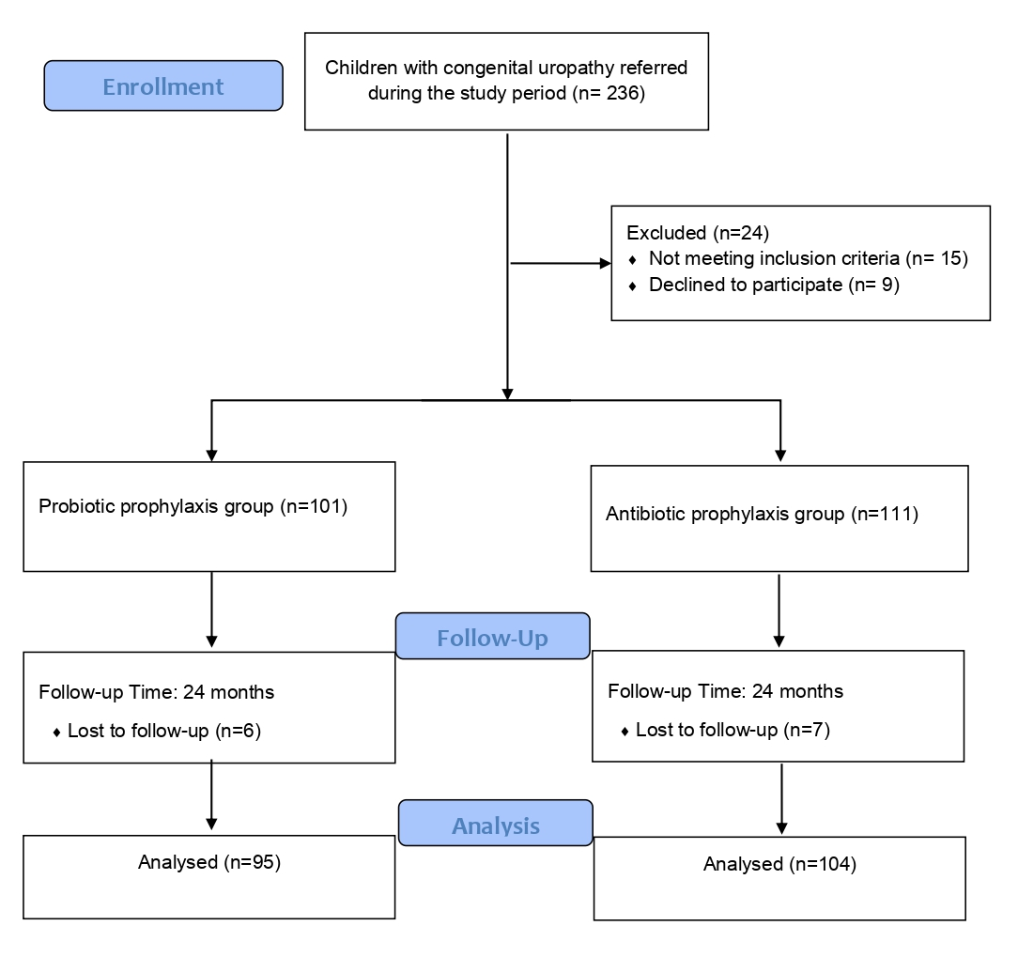
Figure 1: Flowchart of the process of selecting children for the study

Table 1: Baseline characteristics of 199 children with congenital obstructive uropathy in the two study groups
 |  | Antibiotic group (n=95) | Probiotic group (n=104) | P-value
Age (year) |  | 3.4 ± 1.6 | 3.5 ± 1.3 | 0.860
Gender |  |  |  | 0.448
Male |  | 57 (60) | 71 (68.3) | 0.448
Female |  | 38 (40) | 33 (31.7) | 0.448
Severity of the uropathy |  |  |  | > 0.05
Mild | Right side | 22 (22.1) | 22 (21.2) | > 0.05
Mild | Left side | 32 (33.7) | 29 (28.9) | > 0.05
Mild | Both side | 15 (15.7) | 18 (17.3) | > 0.05
Moderate | Right side | 6 (6.3) | 12 (11.5) | > 0.05
Moderate | Left side | 8 (8.4) | 11 (10.6) | > 0.05
Moderate | Both side | 8 (8.4) | 6 (5.7) | > 0.05
Severe | Right side | 1 (1.1) | 2 (1.9) | > 0.05
Severe | Left side | 3 (3.2) | 3 (2.9) | > 0.05
Severe | Both side | 1 (1.1) | 1 (0.96) | > 0.05
Data are mean ± SD or frequency (%)
P-value calculated by independent T-test or Chi square test.

Figure 2: Comparison of recovery time between two studied groups of children with congenital obstructive uropathy

Figure 3: Comparison of recurrence of disease between two studied groups of children with congenital obstructive uropathy

